

Travlr Getaways

CS 465 Project Software Design Document
Version 1.0

Table of Contents

CS 465 Project Software Design Document 1
Table of Contents 2
Document Revision History 2
Executive Summary 3
Design Constraints 3
System Architecture View 3
Component Diagram 4
Sequence Diagram 5
Class Diagram 6
API Endpoints 7
The User Interface 7-8

Document Revision History

Version | Date | Author | Comments
1.0 | 08/16/2026 | Edgar Williams | Initial version of the Travlr Getaways Software Design Document for Milestone One.

Executive Summary

The Travlr Getaways application is designed using the MEAN stack architecture to provide a modern, scalable web application for both customers and administrators. The customer-facing side of the application allows users to browse available travel destinations through a responsive website built with Express and Handlebars templates. Dynamic content is loaded from JSON data, allowing pages to be updated without manually editing the HTML each time new trip information is added. The administrator side of the application is designed as a Single Page Application (SPA) using Angular. Unlike the customer-facing website, the SPA provides a richer user experience by allowing administrators to manage trip information, update existing destinations, and make changes without constantly reloading the page. Express serves as the backend web server while MongoDB stores application data. RESTful API endpoints allow the frontend and backend to communicate efficiently, creating a flexible architecture that can continue to grow as additional features are added.

Design Constraints

Several design constraints influenced the development of the Travlr Getaways application. One of the primary constraints was following the MEAN stack architecture while maintaining a clear separation between the client, server, and database layers. The application also needed to support both a customer-facing website and an administrator interface without duplicating business logic. Using Express, Angular, and MongoDB required each layer to communicate through RESTful API endpoints instead of directly accessing application data. Another design constraint was maintaining the Model-View-Controller (MVC) architecture. Routes, controllers, views, and data all needed to remain organized and separated to improve maintainability as the project grows. Dynamic rendering with Handlebars also replaced static HTML pages, making future updates much easier because content can be modified by changing the data source instead of editing multiple HTML files. These constraints create a more scalable application while reducing maintenance and improving the overall user experience.

System Architecture View

The Travlr Getaways application follows a three-tier architecture consisting of the client, server, and database components. On the client side, users access the application through a web browser. The customer-facing website uses Express with Handlebars templates to render dynamic content, while the administrator interface uses Angular as a Single Page Application to provide a more interactive experience. Requests from the client are sent to the Express server, where routes direct requests to the appropriate controllers. The controllers process user requests, interact with the application's business logic, and retrieve or update data as needed. RESTful API endpoints provide communication between the frontend and backend while separating the user interface from the data layer. MongoDB serves as the database for storing trip information and other application data. Mongoose acts as the object modeling library that allows the Express application to communicate with MongoDB using JavaScript objects. This architecture keeps each component responsible for a specific task while allowing all layers to work together efficiently. As the application grows, additional features can be added without requiring major changes to the existing architecture.

Component Diagram

The component diagram shows how the main parts of the Travlr Getaways application work together. The application is divided into three main layers: the client, the server, and the database. Users access the application through a web browser, where Express and Handlebars generate the customer-facing website. The administrator side of the application uses Angular as a Single Page Application (SPA), giving administrators an easier way to manage trip information without constantly reloading pages. The client sends requests to the Express server, which handles routing, authentication, and the application's business logic before communicating with the database. The server connects to MongoDB through Mongoose to store and retrieve trip information. RESTful APIs allow the client and server to exchange data while keeping each part of the application separate. This design makes the application easier to maintain and expand because each component has its own responsibility while still working together as one complete system. As the application grows, new features can be added without having to redesign the entire application.

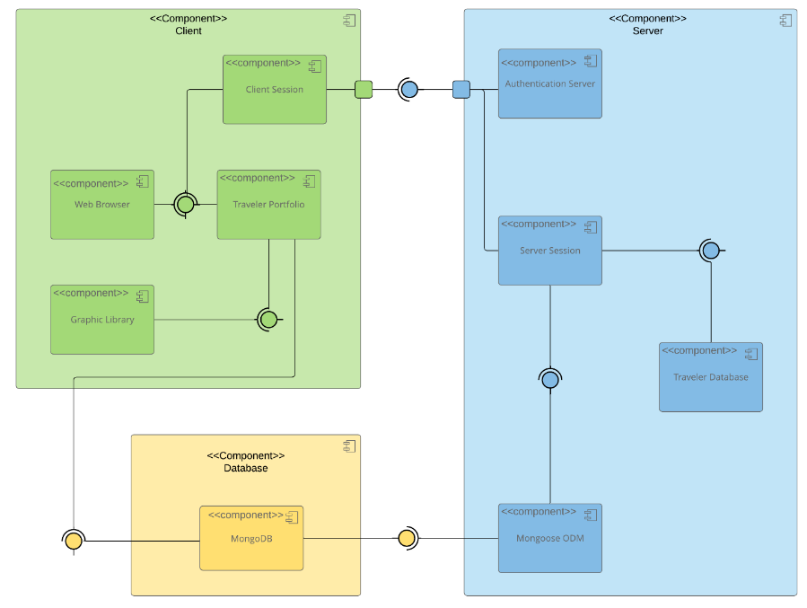

A text version of the component diagram is available: CS 465 Full Stack Component Diagram Text Version.

Sequence Diagram

The sequence diagram illustrates how information flows through the Travlr Getaways application using the MEAN stack architecture. The process begins when a user interacts with the client application through a web browser or the Angular Single Page Application. The browser sends an HTTP request to an Express route on the server. The Express route forwards the request to the appropriate controller. The controller contains the application's business logic and determines what action needs to be performed, such as retrieving all trips, viewing a single trip, or processing an administrator request. The controller communicates with the Mongoose model, which serves as the interface between the Express application and the MongoDB database. Mongoose sends the database query to MongoDB, where the requested trip information is stored. After MongoDB processes the request, the data is returned to Mongoose, which passes the results back to the controller. The controller formats the response as JSON and sends it back through the Express route to the client. For customers, the browser displays the returned trip information using Express and Handlebars templates. For administrators, the Angular SPA consumes the REST API and dynamically updates the interface without requiring a full page reload. Administrative users can sign in, retrieve trips, create new trips, edit existing trips, and delete trips through the same API endpoints. This layered architecture separates the presentation layer, business logic, and database, making the application easier to maintain, expand, and troubleshoot.

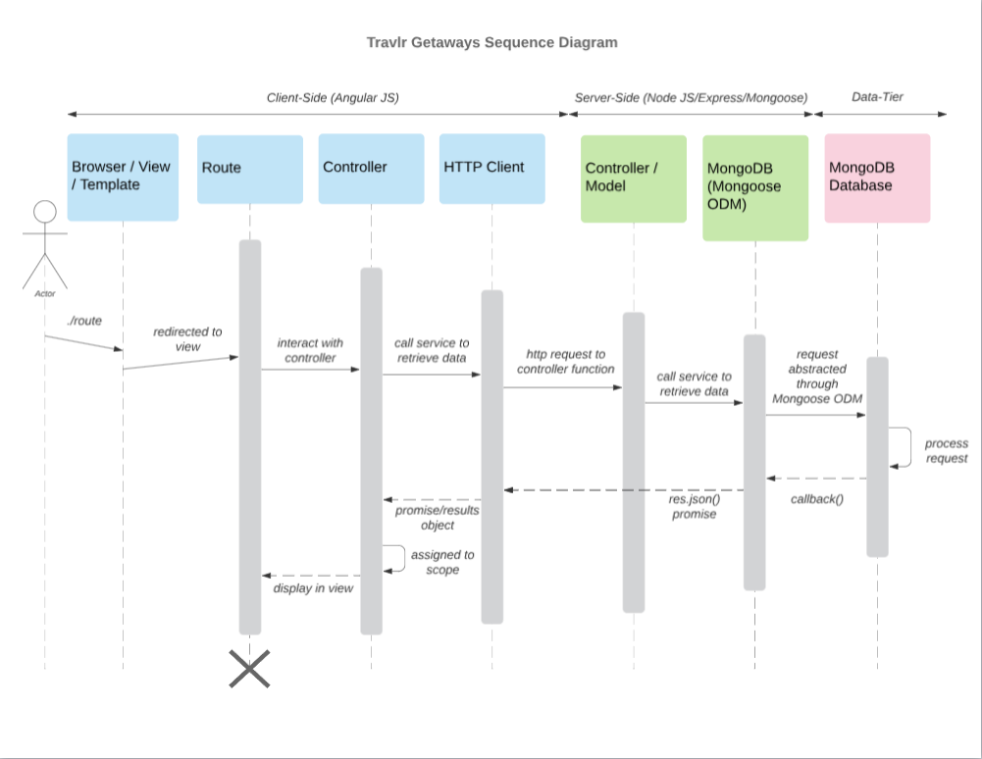

Class Diagram

The class diagram illustrates the primary JavaScript classes used throughout the Travlr Getaways application. At the center of the application is the itinerary and booking process, which coordinates several related classes, including Itinerary, TripInfo, FlightInfo, HotelInfo, CruiseInfo, MemberAccount, Membership_Admin, TravellerInfo, Travel_Agent, HotelBooking, FlightBooking, and CruiseBooking. Each class contains attributes that define the data it stores along with methods that perform specific operations. The Itinerary class manages travel details such as total price, total miles, and stopovers, while TripInfo stores destination, origin, and travel date information. FlightInfo, HotelInfo, and CruiseInfo contain transportation and lodging details associated with a travel package. MemberAccount and Membership_Admin manage customer membership information, reward points, and validation functions. TravellerInfo stores traveler-specific information, while the Travel_Agent class coordinates the booking process by interacting with the HotelBooking, FlightBooking, and CruiseBooking classes. These classes communicate with the client application and interact with the Mongoose models that represent MongoDB collections. Their relationships demonstrate object-oriented concepts such as association, aggregation, and composition, allowing related objects to work together while maintaining separate responsibilities. Separating these classes improves code organization, encourages reuse, and simplifies future enhancements as additional travel features are added.

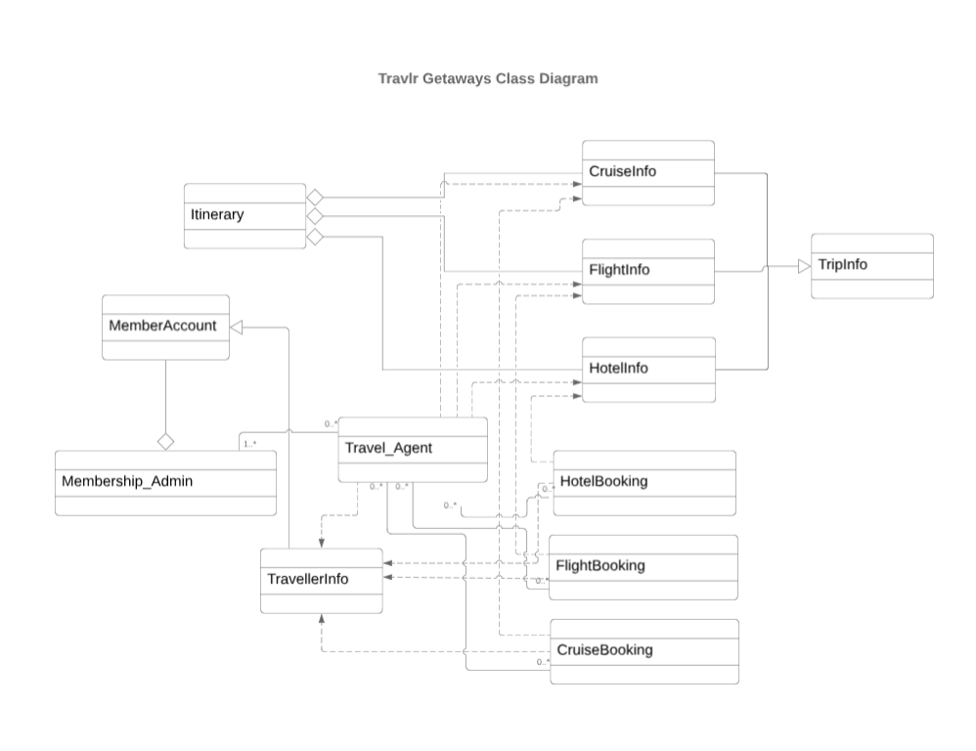

API Endpoints

Method | Purpose | URL | Notes
GET | Retrieve all trips | /api/trips | Returns every trip stored in MongoDB.
GET | Retrieve a single trip | /api/trips/:tripCode | Returns one trip using the trip code.
POST | Create a new trip | /api/trips | Adds a new trip to the database. Used by the Angular admin application.
PUT | Update an existing trip | /api/trips/:tripCode | Updates information for an existing trip.
DELETE | Delete a trip | /api/trips/:tripCode | Removes a trip from the database.
POST | Authenticate administrator | /api/login | Validates login credentials before allowing administrative functions.

The User Interface

The Travlr Getaways administrator interface was developed as an Angular Single Page Application (SPA). The Angular project is organized into components, models, services, routes, and authentication features. Components such as the trip list, trip card, add trip, edit trip, and login pages handle different parts of the user interface. Services are used to communicate with the RESTful API and retrieve or update trip information. The Express application is organized differently because it focuses more on server-side routing, controllers, models, and communication with MongoDB. While Express handles requests and backend processing, Angular provides a more interactive experience because administrators can manage trip information without constantly reloading the entire webpage. The SPA was tested with the RESTful API to make sure trip information could be retrieved and updated correctly. GET requests were used to retrieve trip information stored in MongoDB and display it in the Angular application. PUT requests were tested by selecting an existing trip, changing its information through the Edit Trip form, and saving the changes. After the update was submitted, the application displayed the updated information, confirming that the Angular frontend, Express API, and MongoDB database were communicating correctly. Security was also added to the administrator side of the application. Administrators must log in before accessing protected administrative functions. After a successful login, authentication information is used when sending requests to protected API endpoints. This prevents unauthorized users from adding or modifying trip information while still allowing the public-facing portion of the application to display available trips.

